# 3 - Methodology

## 3.1 - Reading in MIDI files

* Read in midi file
* Midi file made up of various events
  + Note start
  + Note end
  + How hard the note is pressed
* Extract note on/off events
* Created specific struct to hold the information
* As midi files don’t have specific information for rests
* Take the difference between notes as rest, create them as normal notes but the pitch is -1
* The key the inputted song is in is also known
* To make change keys easier later on each note’s pitch gets reduced down to the key of C (if original pitch is A, each note’s pitch is subtracted by 9, the semitone difference between A and C)
* Would also allow multiple songs to be combined at the read in stage

## 3.2 - Markov Chains

### 3.2.1 - Frequency Distributions

The next step in the process is to calculate the frequency distribution of the notes pairs in the inputted song. For each note pair it checks if it is a unique pairing, if this is not the case it increases the frequency counter for that pairing by 1, if it is unique then it creates a new instance of DependHolder and adds that to the list of note pairs. For each note it then sums the number of possible next notes.

### 3.2.2 - Choosing Notes

When choosing notes some stuff happens.

## 3.X - Questionnaire

## 3.X - The Game

### 3.X.1 - Basic Idea

The first objective for designing the game was to determine the most appropriate genre which would provide enough variability in the gameplay to give the music generation application sufficient variability to showcase how it can modify the produced music. The game that was chosen was a first-person stealth game, inspired by Pacman (XXXXXXXXXXXXX, 19XX), the player is tasked with collecting 200 orbs in a sci-fi style facility, while trying avoid the robot guards, shown below in Figure X

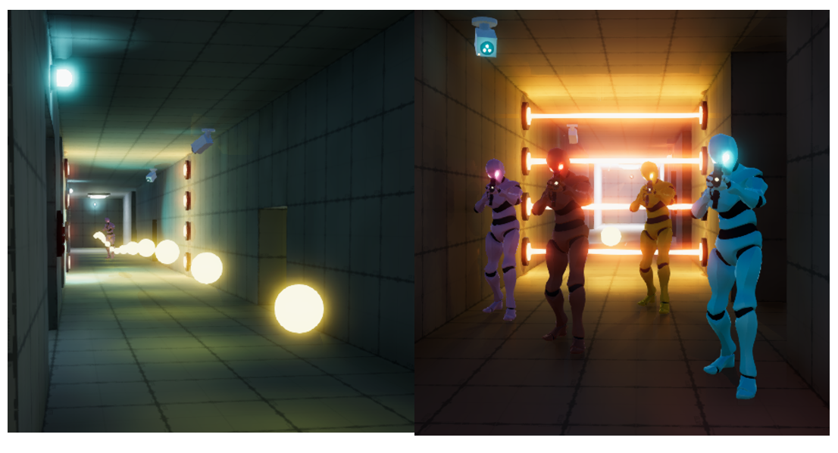

A B

Figure : The orbs the player has to collect (A) and the robots guards they have to avoid (B)

### 3.X.2 - Game Intensity

The first way the game varies the intensity is the player’s movement speed, the player has three options for this; standing still, walking, and running, each having a larger effect on the intensity than the one before.

The player’s interactions guards also has an effect on the intensity, the closer they are to them the higher the intensity is. The guards also have three states they can be in (in order of decreasing intensity);

* Chasing - When they see the player the guards will chase after then, until they can no longer see them.
* Searching - When they lose sight of the player they will go to the players last known location, when they reach this position they will turn in a circle to see if they can locate the player again.
* Patrolling - This is the default state where they follow pre-set paths around the facility.

The player has to also look out for security cameras (top left of in Figure X - B), when they see the player they activate a laser grid which blocks the player’s path (again shown in Figure X - B). To increase the intensity of the game, when half of the orbs are collected the facility goes into ‘lockdown’ mode, which causes the laser grids to be on for the rest of the game, this is change is indicated by a dialogue line and the warning lights (Top right if Figure X - A) change to orange. When 80% of the orbs have been collected the facility goes into ‘hunting’ mode, indicated by another in-game dialogue announcement, the warning lights turning red, and an alarm playing. The robot guards at this point actively hunt down the player, by permanently being in the ‘Chasing’ state. These two changes actively increase the intensity of the game and thus increase the intensity of the music.

### 3.X.3 - Game Valence

The first variable that effects the music’s valence is the number of orbs collected as this is the main way the player will track their progression, the higher this is the higher the valence is. The second is the number of lives the player has, they start with three and each time they come into contact with a guard they lose a life, and the valance is decreased. The state the guards are in effects the valance in a similar way that it effects the intensity, although for valence it has a negative effect.